Environmental and Experiment’s conditions

Some of the most important measurements of the experiment were the pressure (P), temperature (T), and humidity (H) determination inside and outside the experiment. These variables are measured inside the Sensorbox (using the index “in”), and outside the Sensorbox while inside the Ecobox (using the index “out”). The environmental conditions (using the index “env”) were not measured by the experiment’s components, but they are provided by the BEXUS gondola.

In the following paragraphs these measurements, alongside others relevant to temperature, will be presented.

# Ascending

The variables Tout and Pout as functions of the gondola’s altitude are given in the below graph, regarding the ascending phase.

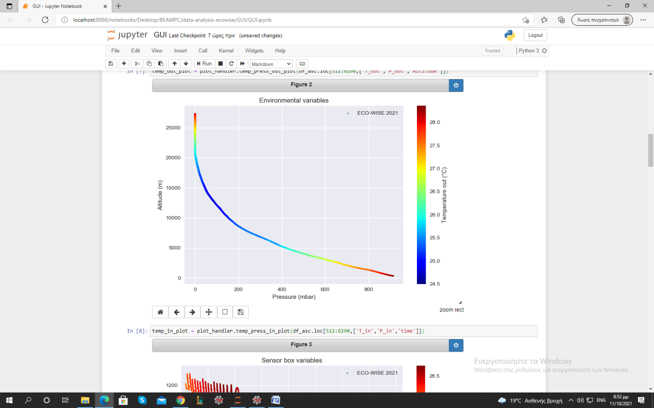

Graph 1: Environmental variables (P, T)

The extrema values of Tout were [24.5 oC, 28.5 oC]. In comparison with the ambient temperature, these are extremely high, even without being inside the Sensorbox. Παραπομπή στο Thermal για την αιτία αυτού. (Γιώργος)

The ascending phase ended at 27.3 km, and it was linear. The mean gondola’s velocity was about 3.7 m/sec.

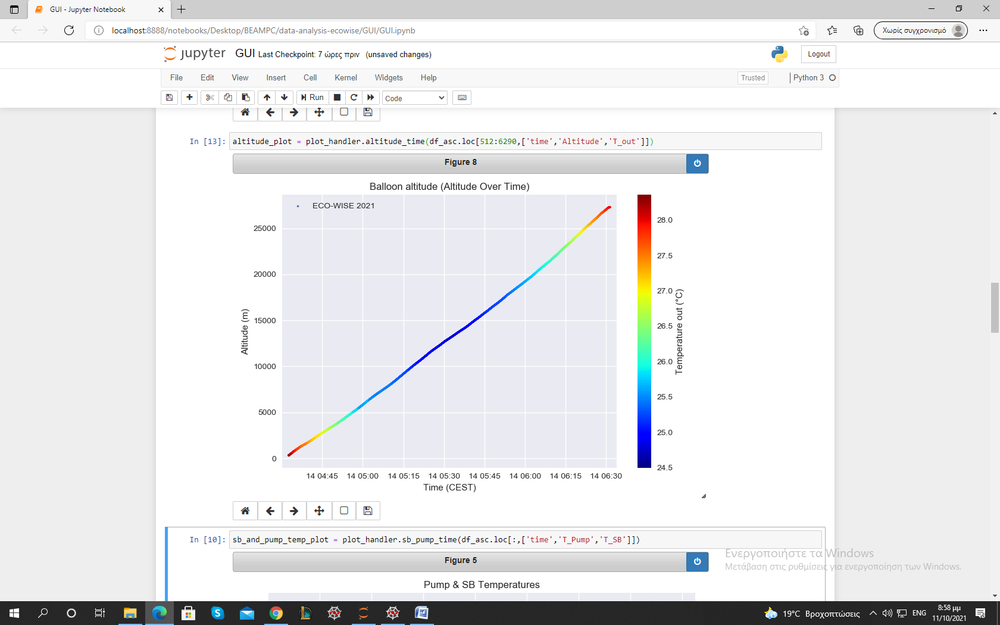

Graph 2: Balloon altitude over time

The sensor’s and the pump’s temperatures were also very high in comparison with the ambient. We observe similar behavior during this phase. These components also contributed to the thermal preservation of the whole experiment.

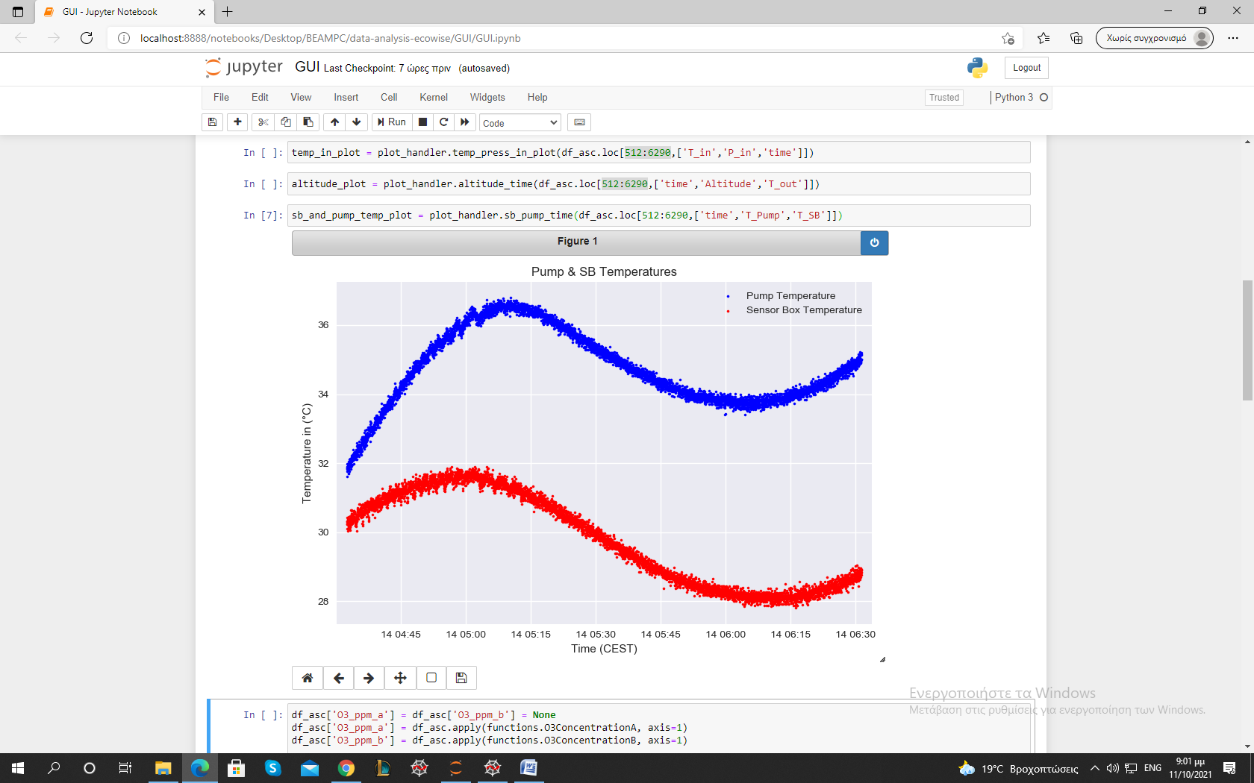

Graph 3: Pump and sensor temperature

Humidity inside and outside the sensorbox throughout the ascending phase was within the specified performance requirements. The extrema values of the outside Humidity were measured to be 1.03% and 19.79%. Humidity inside the box was measured to be greater than outside at every stage but also steadily declining while the balloon was ascending, with its extrema values being ranging from 4.35 % to 26.2 %. The periodic fluctuation in humidity due to the pump’s function can clearly be seen in the graph.

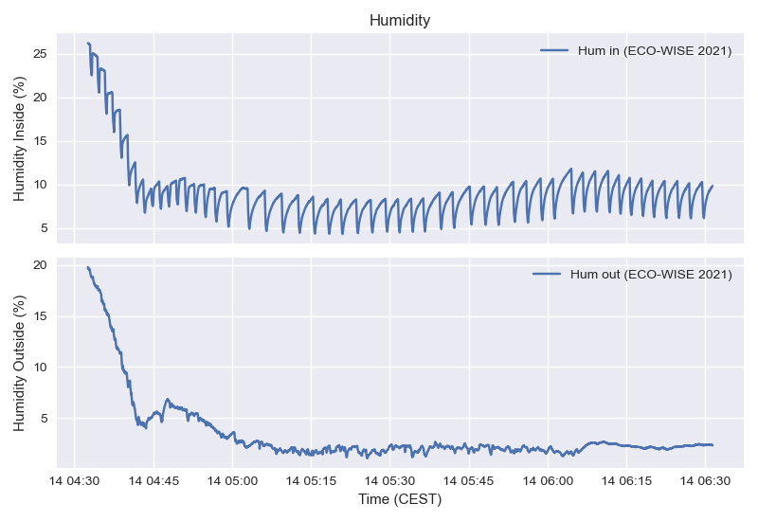

Graph 4: Humidity measures inside and outside of the sensorbox

However, when comparing the measurements for outside Relative Humidity from [BEXUS] and [ECOWISE] there is an obvious significant deviation.

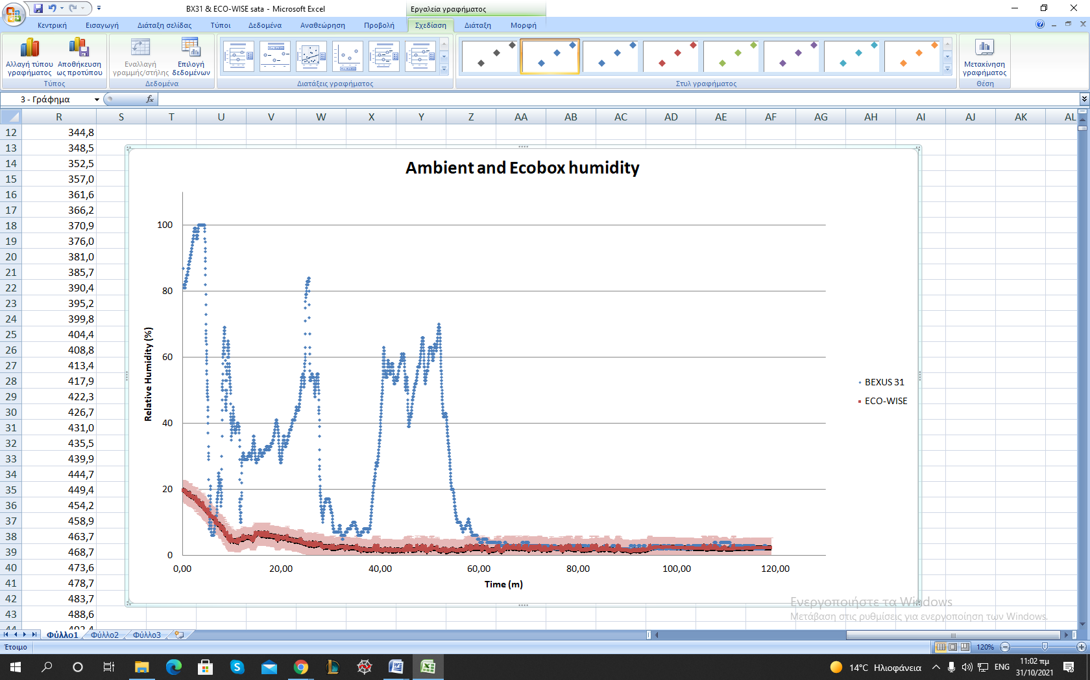

Graph 5: Relative Humidity (ambient and outside) as a function of time

This deviation can be explained by considering the difference in outside temperature measured. As can be seen below, the ambient temperature measured by the ECOWISE sensors remained practically stable whereas the actual ambient temperature, as was expected, steadily declines, and reaches a plateau at greater altitudes. Thus, taking into account the inverse proportionality between temperature and relative humidity, the differences in measured RH can be safely attributed to the temperature difference.

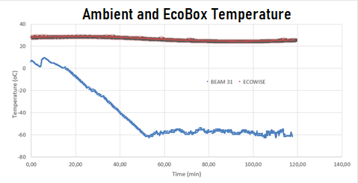

Graph 6: Ambient and outside temperature as a function of time

The temperature and pressure inside the sensorbox as a function of time during the ascending phase are presented below.

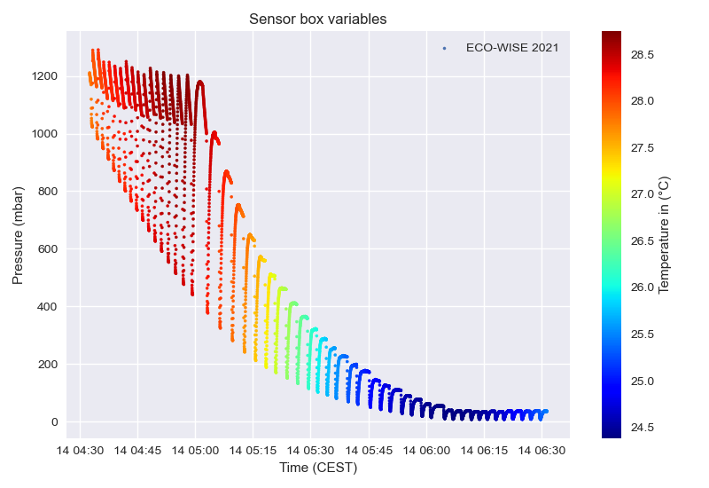

Graph 7: Sensorbox Variables (Ascending phase)

The inside temperature remained well within the specified range of [-40 oC, 60 oC ] throughout the ascending phase. In fact, it remained surprisingly stable between 24 oC and 29 oC which indicates that HEATERS???? Λειτουργια αντλιας;; insulation? (Γιώργος). The temperature’s stability can be seen better in the graph below.

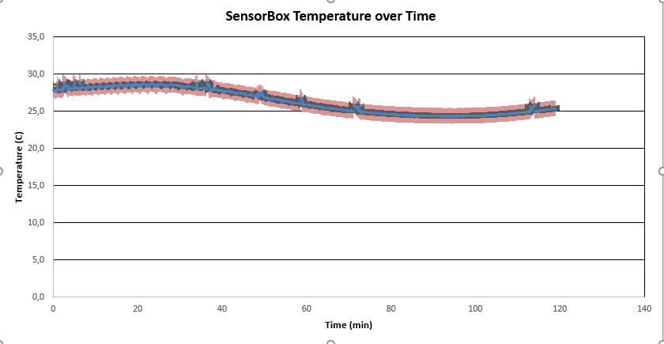

Graph 8: The temperature inside the sensorbox remains remarkably stable throughout the experiment

Conversely, the pressure inside the sensorbox did not meet the performance requirements during the ascending phase (pressurization up to at least 800mbar at every cycle). The repeated cane shaped curves seen above represent each cycle. The pressure starts off equal to the ambient pressure and the pump steadily pressurizes the air in the chamber. Afterwards, it remains constant for a short time frame, when measurements are taken, and then quickly drops back to the atmospheric pressure while all the valves are open. As is evident in the graph above, the pump was not able to continuously raise the pressure sufficiently after the ambient pressure was lower than 280 mbar. Unfortunately, it was determined that there was a leak somewhere in the sensorbox which resulted in the pressure inside essentially matching the atmospheric pressure during almost every stage. It should be noted that the selected pump could have perhaps not been perfectly suited for the required pressurization but it is hypothesized that it would yield acceptable results were it not for the leak. The measured extrema values were [6.5 mbar, 1290.9 mbar].

The ambient pressure and temperature, as well as the altitude of the experiment over time were also measured by independent sensors, and the data are provided by the BEXUS organizers.

In the following graph, the pressure measurements over altitude are presented. The pressure inside the sensorbox follows the periodic behavior mentioned above, with its minimums being inside the accepted error area of Pout for the higher altitudes. This was expected by the construction of the experiment’s stages, since all the valves are open during stage 3. Thus, Pin should equal Penv, or the ambient pressure. The ecobox was not airtight, so the ambient pressure equals Pout, as the graph implies.

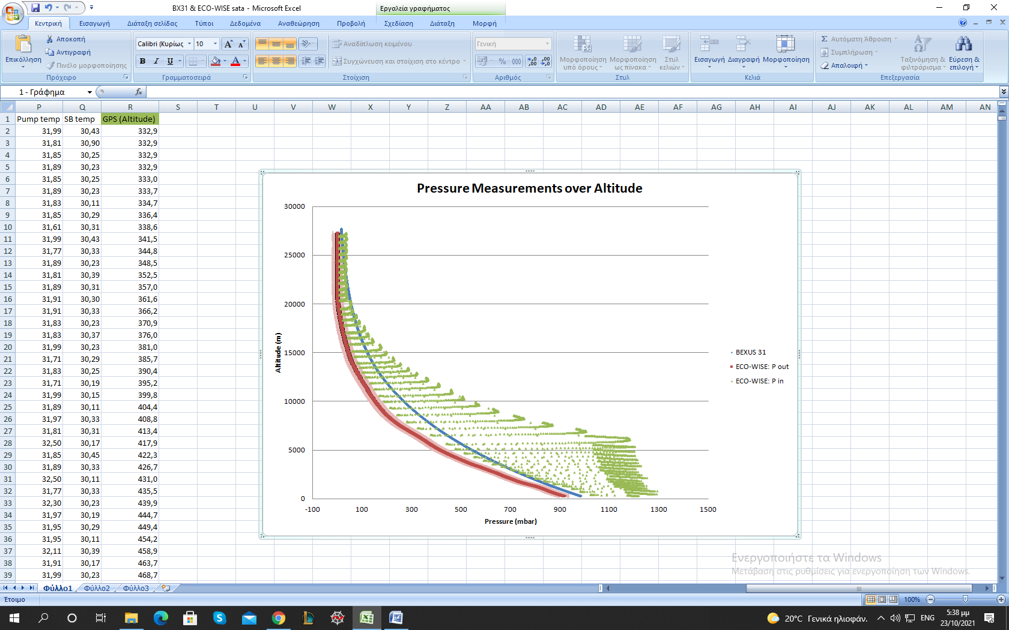

Graph 9: Pressure measurements

As the altitude decreases, the abovementioned equivalence between Pin and Pout disappears. Taking the pump’s behavior into account, this could be explained by its power, since the pump was providing a high flow rate which could not be compensated by the decompression in the given time period of stage 3. Namely, if the pump’s flow rate is quantified by a function “f”, then it is a function of both Penv and (Penv – Pin). Considering that Pin increases over time, during stage 1, it stands to reason that “f” is also a function of time. Therefore, for higher values of Penv, “f” gives higher flow rate and thus more time, than the duration of stage 3, is required for (Penv - Pin) to equal zero.

This graph also shows the ambient pressure measured by the independent sensors. There is a significant systematic deviation between the two sensor’s measurements. A possible explanation is that the two sensors used were strongly affected by the temperature difference, which was up to 90 oC. Since the analysis regarding pressure requires compatible measurements, the data that will be used are from the experiment’s sensors: ECO-WISE: Pout and Pin.

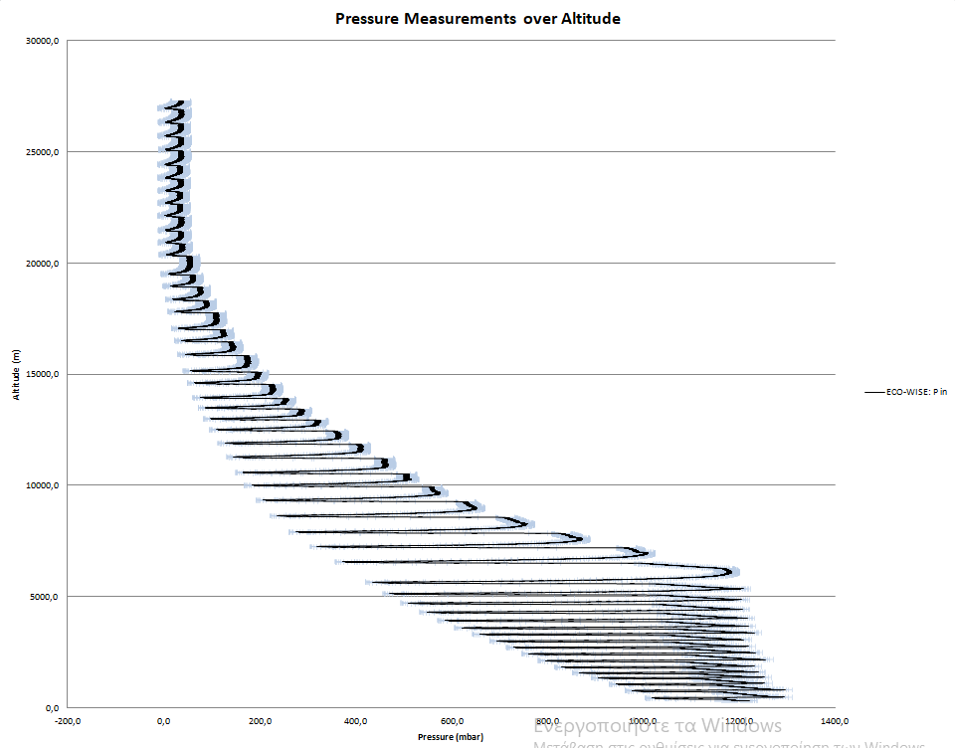

Graph 10: Inside Pressure Graph including the error margins

In addition to the Balloon’s altitude measurements by the experiment’s GPS, the following graph presents the independent altitude data. In the lower altitudes the two independent measurements are almost equivalent. A systematic deviation appears as the altitude increases, but its order of magnitude in comparison with the experiment’s targets is negligible and it will not be taken into further consideration.

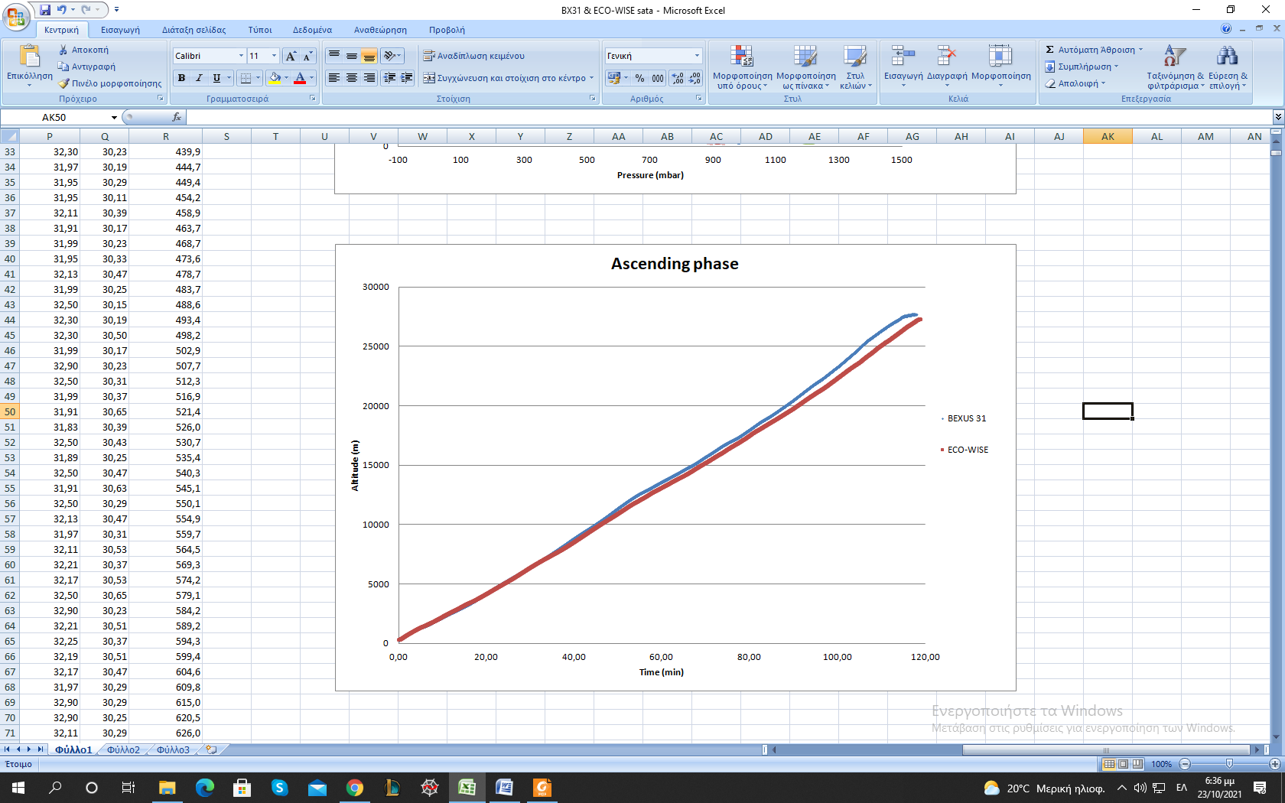

Graph 11: Altitude measurements during ascending phase

The ambient temperature measurements from BEXUS 31 are presented below.

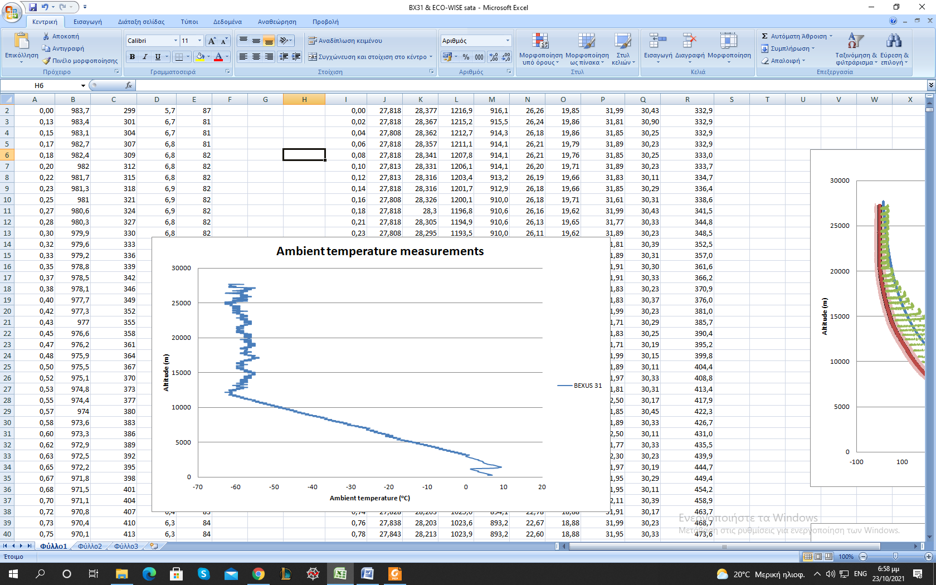

Graph 12: Ambient temperature measurements from independent sensors

# Floating

During the floating phase the pressure was extremely low and therefore the pressure sensor was not reliable. There are even negative outputs.

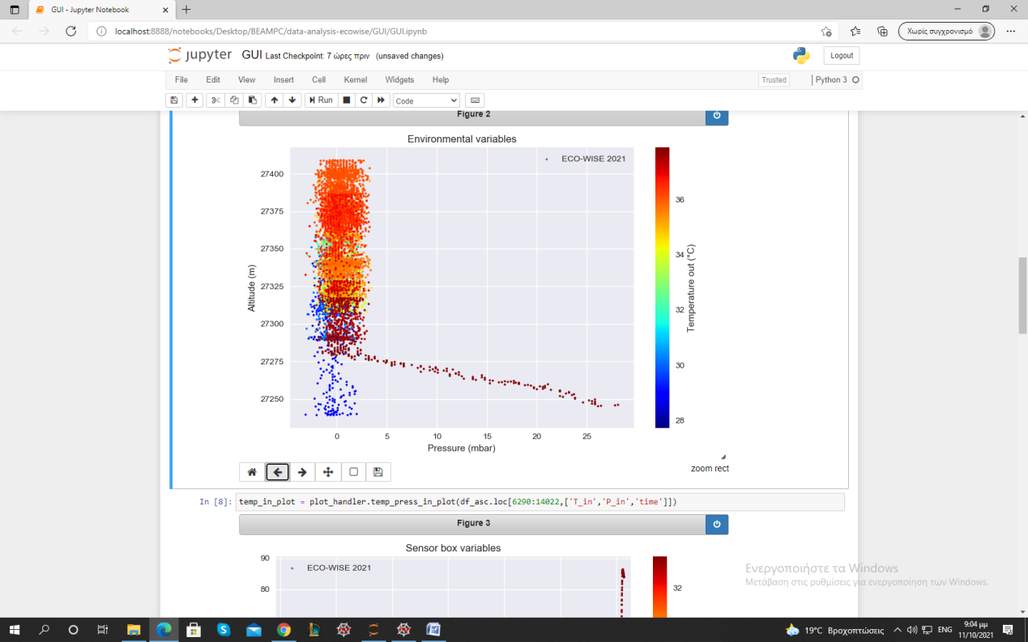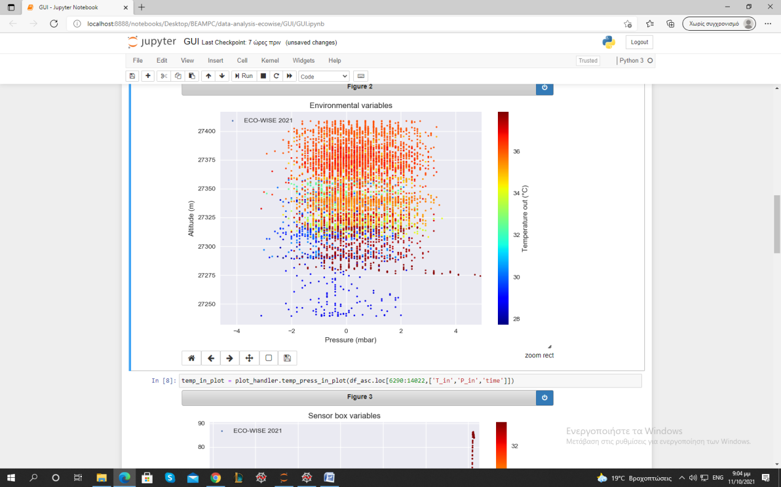

Graph 13: Ambient pressure during floating phase

In these altitudes we expect the pressure to be less than 20 mbar. Since the error of the sensor is ±20 mbar in the temperature range [0 oC, +40 oC], the pressure measurements are not valid during this phase.

The fluctuations in the altitude during the floating phase are presented in the following graph. In this phase the connection was lost for some minutes and this is the reason of the first wide gap in the data. The other discontinuities are attributed to the restarting of the experiment in order to change the maximum value of Pin, since the pump was not capable of reaching the initial pressure target.

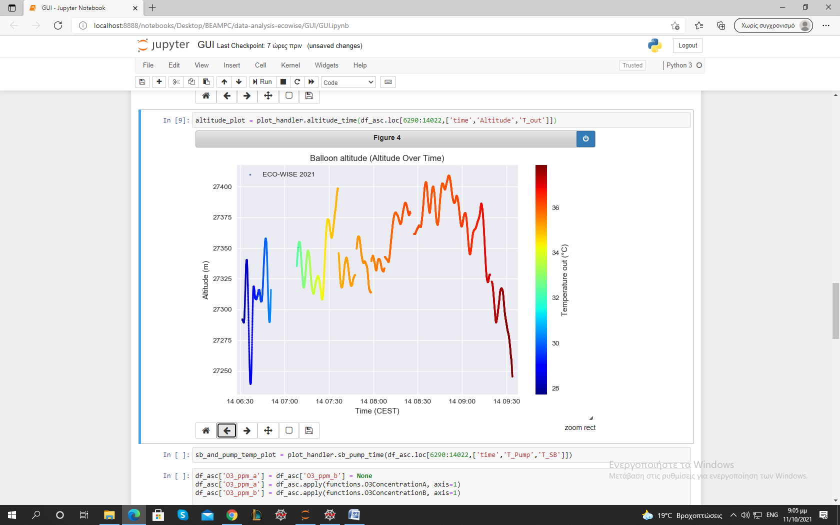

The component’s temperature in the floating phase increased. ΓΙΑΤΙ??? (Γιώργος)

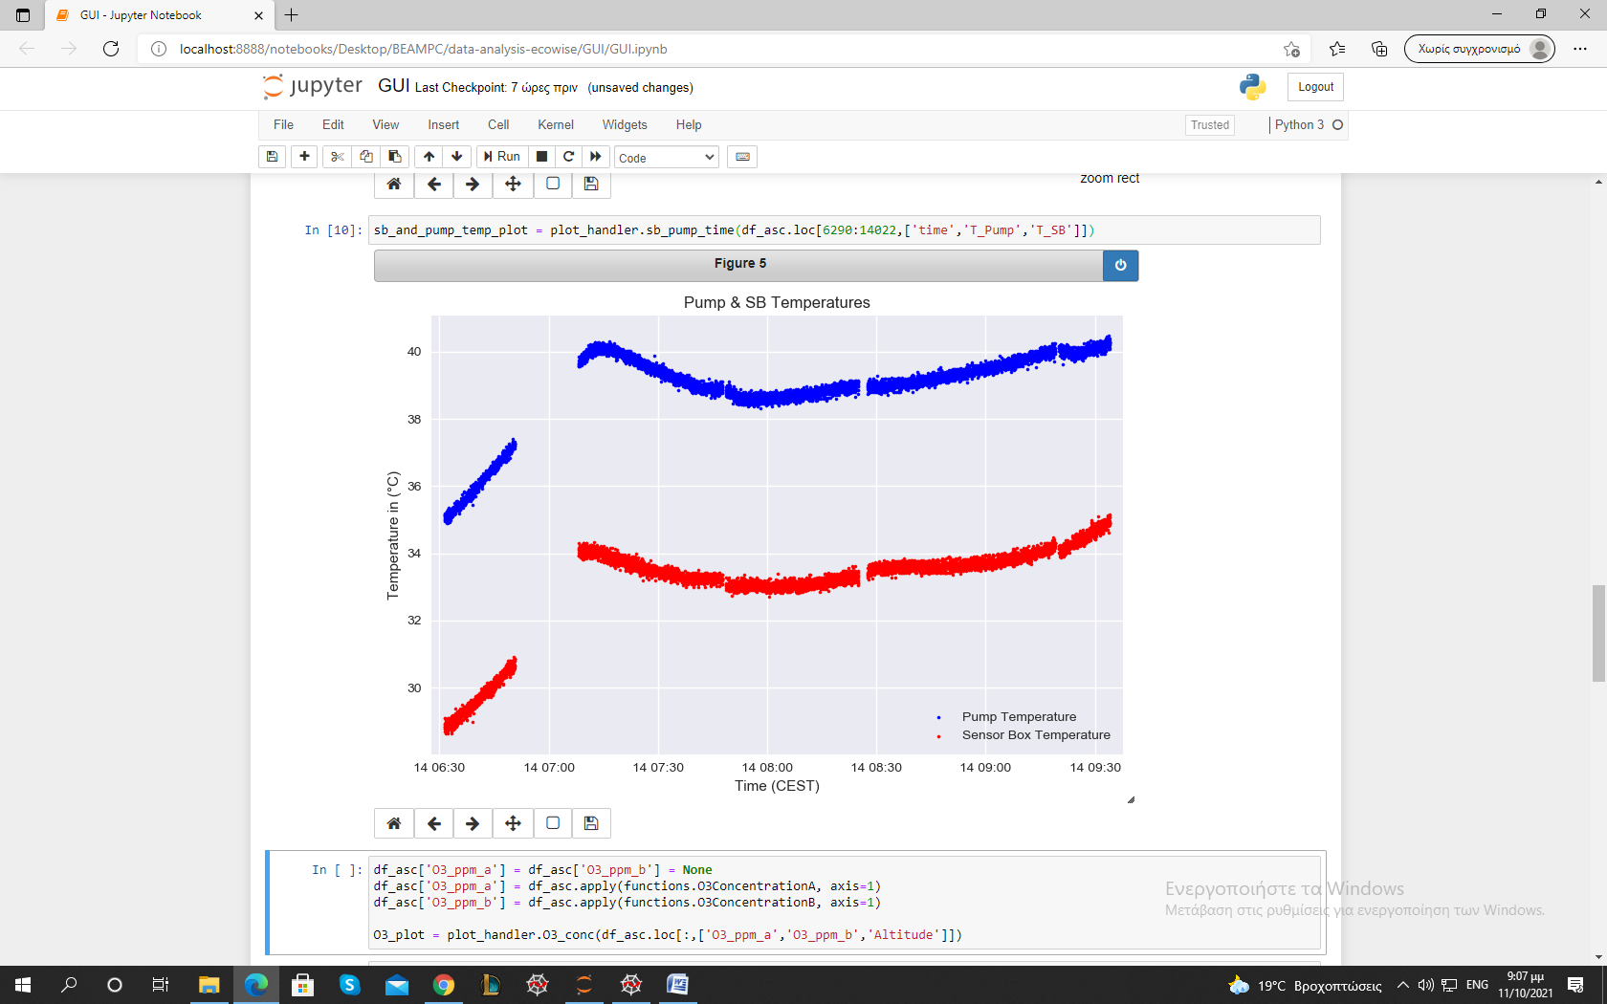

As mentioned above, there exist certain discontinuities in the graphs below which are attributed to a loss of signal as well as the resbooting of the experiment’s systems.

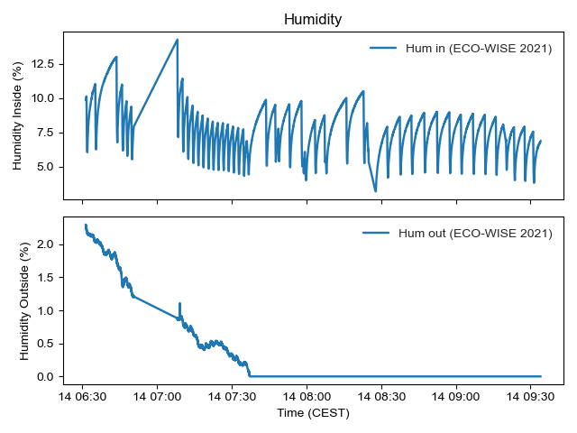

Graph 14: Humidity inside and outside of the sensorbox during the floating phase

The outside humidiity remained relatively stable throughout the floating phase and any changes were mostly gradual with its values ranging from 0 % to 2.3%. The humidity measured inside however, as can clearly be seen in the graph, varied greatly and changed periodically with every cycle, with its extrema values being [3.17 %, 14.29 %].

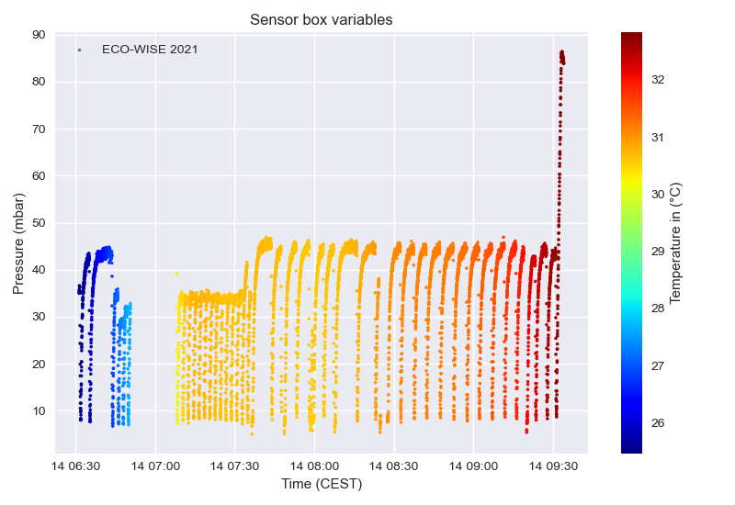

Graph 15: Sensorbox variables during the floating phase

Again, the temperature inside the sensorbox remained relatively stable and slightly higher during the floating phase, in the range [25.5 oC, 32.5 oC]. The inside pressure remained extremely low, and the pump could only raise its value up to 47 mbar with the minimum pressure being 5 mbar.